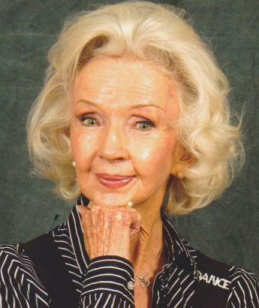
Jean Phelps Veloz, now in her 90s, appeared in the Kay Kyser movie “Swing Fever.” She garnered national attention when she recently appeared on Steve Harvey’s Little Big Shots: Forever Young program, where she danced the same routine from the movie with the clip from the original running at the same time in the background.

She sends her thoughts and regards:
“Congratulations to all on this wonderful dedication of the Kay Kyser historic marker.
I met Kay Kyser in 1943, when I was a featured dancer in his movie, SWING FEVER. It was the ONE GIRL AND TWO BOYS number, and I won the part in a big Los Angeles dance competition. Kay Kyser was great… I just adored him! He was so up. He was fun to be with, smiles, and so appreciative of our dancing, and so complimentary. He was wonderful to us kids. He said: ‘Keep the camera on the dancers.’ That’s why you see the whole number. In other movies, they always cut away from the dancers, but Kay Kyser insisted they keep that camera on us. Oh, boy! He gave us closeups that nobody ever got, and he gave us carte blanche to do whatever we wanted in our dance. I always remember him with such fondness. That dance scene has gone down in history as one of the great Swing Dances on film, and wherever I go, people want to see it, and love it, and I always tell them about how wonderful Kay Kyser was to us.
All my best wishes to his family and friends there today.”

